Latinx Veterinary Medical Association at Iowa State University College of Veterinary Medicine
Student Chapter 2022-2023

CONSTITUTION & BYLAWS

ARTICLE I
Name & Logo

1.1 Name. The name of the organization shall be Latinx Veterinary Medical Association at Iowa State University, abbreviated LVMA at Iowa State University, and herein referred to as the Latinx Veterinary Medical Association at Iowa State University.

1.2 Logo. The national organization logo is to be used in documents, paraphernalia, and events associated with the Chapter of the Latinx Veterinary Medical Association. Adaptations and alterations of the national organization logo may be created to incorporate the specific school name of Iowa State University. Adaptations and alterations of the national organization logo must retain the colors and font type of the original logo.

ARTICLE II
Purpose and Mission

2.1 Purpose.
(i) Provide a network of Latinx/Hispanic veterinary students
(ii) Increase visibility of Latinx/Hispanic veterinarians and veterinary students
(iii) Create networking opportunities for Latinx/Hispanic veterinary professionals and students
(iv) Promote inclusion of Latinx/Hispanic professional students in the veterinary field
(v) Support aspiring Latinx/Hispanic veterinarians through community, mentorship opportunities and scholarship, and other resources
(vi) Promote the veterinary profession to Latinx/Hispanic youth via community outreach and media communications

2.2 Mission. To empower Latinx/Hispanic students and professionals in veterinary medicine and support aspiring Latinx/Hispanic veterinarians in order to better serve client demographics or “the next generation of Latinx/Hispanic veterinarians”.

2.3 Vision. To help create a veterinary workforce that is representative of our society in order to make veterinary care more accessible to the Latinx community.

ARTICLE III
Statement of Compliance:

Latinx Veterinary Medical Association at Iowa State University abides by and supports established Iowa State University policies, State and Federal Laws and follows local ordinances and regulations. Latinx Veterinary Medical Association at Iowa State University agrees to annually complete President’s and Treasurer’s Training.

ARTICLE IV
Non-Discrimination Statement:

Iowa State University and Latinx Veterinary Medical Association at Iowa State University do not discriminate on the basis of genetic information, pregnancy, physical or mental disability, race, ethnicity, sex, color, religion, national origin, age, marital status, sexual orientation, gender identity, or status as a U.S Veteran.

ARTICLE V
Membership:

5.1 Membership. Membership shall be granted to veterinary students.
LVMA at Iowa State University will not discriminate on the basis of sex, race, color, age, national origin, religion, disability, genetic information, marital status, sexual orientation, gender identity/reassignment, gender expression, citizenship, pregnancy or parental status, veteran or military status, educational background, or any other status protected by applicable national, federal, state or local law.
5.2 Annual dues $0 per semester (for the first year, then this can be revised) must be submitted to the Treasurer. Members shall be entitled to the privileges of membership as defined by these bylaws for the fiscal year in which they have paid dues.
5.3 Active membership status will apply for all members of LVMA at Iowa State University who:
(i) Has paid the dues set by the executive board
(ii) Completed all other membership requirements set by the executive board, and
(iii) Are in good academic standing according to the university’s academic policies
5.4 Student Members. Students enrolled in US-accredited colleges of veterinary medicine (including schools within Canada & the Caribbean) may become a Student Member.
(i) These members are held to at least the same standards as the general veterinary Student Membership.
(ii) In the event where a vote shall be required from the chapter at large for a school specific event, active student members may participate.

ARTICLE VI
Officers:
6.1 Officers. The Executive Officer Board of LVMA at Iowa State University is to be reported to LVMA National by June 1st annually. Members voted into office shall comprise the Executive Officer Board LVMA at Iowa State University. Required officer positions of LVMA at Iowa State University shall be:
(i) President/ Vice-President, alternatively co-Presidents
(ii) Secretary
(iii) Treasurer
6.1.2 Optional officer positions may be established, including but not limited to: Social Chair, Public Relations, Alumni Chair, and Service Chair

6.2 Duties. The officers shall perform the duties as are prescribed for the office in these bylaws, by LVMA National, by the President, or in the adopted parliamentary authority.
6.2.1 The President/Co-President shall be the chief elected officer and official spokesman of LVMA at Iowa State University and shall see that all orders and resolutions of the Board are carried into effect. She/He/They shall be an ex-officio member of all committees. The President shall preside at all meetings of the membership.
6.2.2 The Vice President shall, in the event of a vacancy in the office of President, automatically become President for the remainder of that term and the term for which elected. The Vice President shall serve as Presiding Officer at meetings of the Association and Board during the absence of the President. The Vice President shall oversee the officers at large.
6.2.3 The Treasurer shall take primary responsibility for all financial transactions of LVMA at Iowa State University. She/He/They shall submit monthly reports to the chapter’s Executive Board. The Treasurer shall have approval of the President(s) and/or the Executive Board for all expenses. She/He/They shall maintain accurate records of all transactions by keeping all receipts and notice of expenditures and handle the collections/disbursements of any monies for LVMA at Iowa State University. The Treasurer shall assist the Secretary in assuring that all members are in good standing and shall preside over any chapter fundraising events.
6.2.4 The Secretary shall maintain or oversee the maintenance of the books and records of the organization. The Secretary shall record the proceedings at every scheduled LVMA at Iowa State University meeting, establish and maintain the chapter’s membership listserv and/or contact list; send to all members a summary of the minutes taken at all general body and Executive Board meetings; send all members adequate publicity of all LVMA events; have custody of all official books, records and papers of LVMA at Iowa State University including the Constitution and Bylaws, their amendments and the minutes of all proceeding. Notify members of all correspondence received for. Handle Membership promotion and records for theLVMA at Iowa State University . The Secretary shall act as President in the absence of the President and Vice-President.

6.3 Terms of Office. The term of office of all officers in the Executive Board shall be one year.

6.4 Nomination and Elections.
6.4.1 Only members in good standing shall be considered for membership into the Executive Board.The officers of this organization must meet the following requirements:
(a) Be in good standing with the university and enrolled: at least half time (six or more credit hours), if an undergraduate student (unless fewer credits are required to graduate in the spring and fall semesters) during the term of office, and at least half time (four or more credits), if a graduate-level student (unless fewer credits are required in the final stages of their degree as defined by the Continuous Registration Requirement) during their term of office.

(b) Have a minimum cumulative grade point average (GPA) as stated below and meet that minimum GPA in the semester immediately prior to the election/appointment, the semester of election/appointment, and semesters during the term of office. For undergraduate, graduate, and professional students, the minimum GPA is 2.50. In order for this provision to be met, at least six hours (half-time credits) must have been taken for the semester under consideration.

(c) Be ineligible to hold an office should the student fail to maintain the requirements as prescribed in (a) and (b).
6.4.2 Appointments to the Executive Board shall be considered and approved by the current Executive Board.
6.4.3 Majority vote will decide the appointment of a new officer.
6.4.4 Appointments should be made annually during the month of April
6.4.5 New appointments shall be made known to the chapter at large.

6.5 Method of selection or election of officers:
Members in good standing can nominate themselves or friends for any executive position. Selected or elected members will email a paragraph to the executive board stating their interest for the desired position (this is subject to change with any new executive board). After candidates display their interest, the executive board officers will vote. A simple majority vote is required to elect an officer.

6.6 Risk Management Officer
Participants will be required to fill out the university universal waiver form prior to participating in any off-campus outreach events or on-campus events with live animals. In the event of an emergency/injury, present members of the executive committee as well as the supervising veterinarian or adviser are responsible for contacting the listed emergency contact as well as any necessary emergency personnel. Member’s emergency contacts are kept on file.

6.6.1 Officers in charge of risk management: The co-presidents of LVMA are the officers responsible for risk management. Duties include:
(a) help minimize potential risks for club activities,
(b) recommend risk management policies or procedures,
(c) to submit documentation to ISU’s Risk Management Office and
(d) to ensure that proper waivers and background checks are on file with Risk Management for events (if applicable).

6.7 Impeachment/Removal of officers Impeachment or removal of an officer may be considered if an officer fails to uphold the duties of their position or commits wrongdoing against another club member. Examples of impeachable offenses include, but are not limited to embezzlement or discrimiation. Impeachment proceedings may be initiated by a written complaint submitted to the President. If impeachment charges are being brought against the President, the written complaint should be submitted to the Vice President. To move forward with impeachment proceedings, 2/3 of executive officers must vote to continue the removal process. The officer being impeached should be notified at least 2 weeks before the general impeachment hearing. The officer will have 5 minutes to speak in front of the general membership, then a secret ballot will be held. An officer can be impeached by a simple majority vote of due-paying members.

6.8 Replacement of officers To fill an officer vacancy, a special election will be held within two weeks of the previous officer’s leave. The special election will follow the same procedures as general elections.

ARTICLE VII -
Adviser:
7.1 The Adviser of this organization shall attend executive meetings, maintain communication with university administration, and assist with the leadership development of the organization’s officers.

7.2 Method of Election/Selection of Adviser(s) The Adviser of this organization shall be selected by a unanimous decision of the executive officers.

7.3 Adviser(s) Term of Service The Adviser of this organization shall serve an indefinite term length at their leisure.

7.4 Impeachment/Removal of Advisers - Impeachment proceedings for the Adviser shall follow the same format as Officer impeachment proceedings.

7.5 Replacement of Advisers - In the event of an open adviser’s position, a replacement elected using regular election procedures shall occur.

ARTICLE VIII
Finances:

8.1 All monies belonging to this organization shall be deposited and disbursed through a bank account established for this organization at the Campus Organizations Accounting Office and/or approved institution/office (must receive authorization via Campus Organizations Accounting Office). All funds must be deposited within 48 hours after collection. The Adviser to this organization must approve and sign each expenditure before payment.

8.2 Budget. A budget for the ensuing fiscal year may be approved annually by the Executive Board. An approved budget shall not be overspent without written approval of the Executive Board. Funds allocated for one function shall not be transferred to another function without written approval of the Executive Board.
8.2.1 Required/Annual membership dues shall be instituted at the discretion of the Executive Board.
8.2.2 Membership dues shall not exceed five dollars ($5.00) per semester or ten dollars ($10.00) per academic year.
8.2.3 Chapters may obtain funding from university or college activity funds or via local small-scale fundraising events (i.e. taste fairs, craft sales, etc).
(i) Funds obtained must go directly into the chapter’s financial account and must be listed in the Chapter’s Reporting to the LVMA National Executive Officer Board
(ii) Individual chapters are NOT permitted to solicit ANY corporate entity for funding without prior approval of the LVMA National Executive Officer Board

8.3 Signing Authority. The President, Vice President, Secretary, and Treasurer and other individuals approved by the Executive Board shall be authorized to co-sign financial transactions within the confines of the approved budget.

8.4 Dissolution
8.4.1 Process. The Association can be dissolved provided all outstanding obligations of the Association have been satisfied.

8.4.2 Inurement. No part of the net earnings of the Association shall inure to the benefit of, or be distributed to, any officer, member or other private party, except that the Association shall be authorized and empowered to pay reasonable compensation for services rendered.

8.4.3 Final Payments and Assets. Upon the dissolution of the Association, the Executive Board shall, after paying or making provision for the payment of all the liabilities of the Association, dispose of all of the assets of the Association exclusively for the purposes of the Association, Iowa State University Latinx Veterinary Medical Association student chapter, or to such organization deemed as aligning with the LVMA purpose and mission, or in such manner, or to such organization or organizations as shall at the time qualify as an exempt organization or organizations under the same section of the Internal Revenue Code of 1986, as amended (or any corresponding provision of any future United States Internal Revenue law), as is the Association, as the governing body of the Association shall determine.

ARTICLE IX
Amendments and Ratification:
A proposal to amend this constitution may be extended to Officers by any voting member of the organization. Proposals should be presented to the general membership at least one week before the vote. A constitution may be amended with a 2/3 vote of due-paying members. The amended constitution will be submitted within 10 days to Student Engagement for approval.

9.1 Proposals. Amendments may be proposed by the Executive Board on its own initiative, or upon written petition by members, addressed to the Board.

9.2 Approval. These bylaws may be amended at any regular meeting by a majority vote of the Executive Board, provided that the amendment has been submitted in writing at least 30 days in advance of the meeting. Amendments should be made known upon time of submission, or renewal, to the National LVMA association.

Acknowledgement of Review by Executive Board & Faculty Advisor:

Co-President: 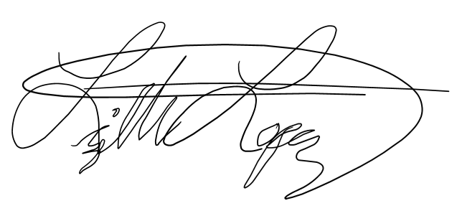
Lizeth Lopez

Co- President: _Niurka Cubero Martinez____

Secretary:

Regina del Mar Castejon Brignoni

Treasurer:
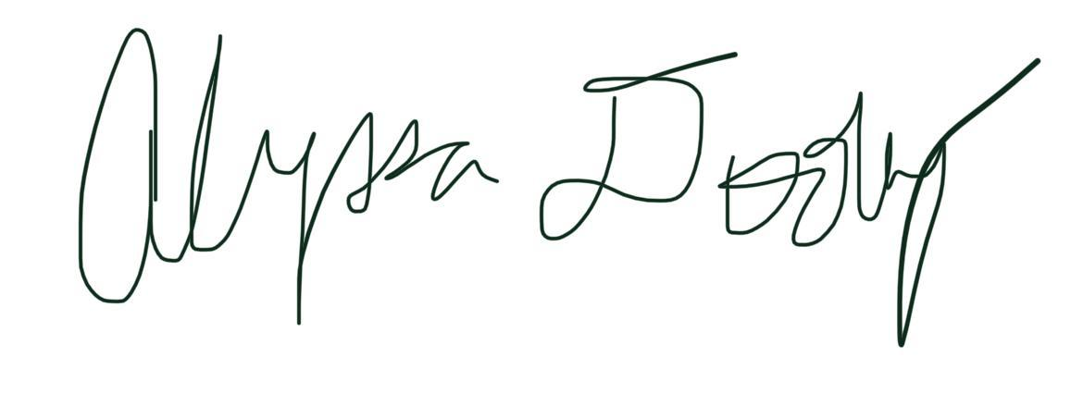
Alyssa Dooley_______________________

Faculty Advisor: Marcelo Almeida
Marcelo Almeida

Faculty Advisor: Pablo Pineyro
