CONSTITUTION
of the
POLITICAL SCIENCE CLUB
at
IOWA STATE UNIVERSITY

Table of Content
Article I: Name………………………………………………………………………………P.2
Article II: Purpose, Mission, and Vision…………..……………………………….………P.2
Article III: Statement of Compliance………………………………………………………P.3
Article IV: Non-Discrimination Statement……………………………………....…………P.3
Article V: Values………………………….…………………………………...…………..…P.3
Article VI: Membership……………….……………………….…………....…..………..…P.4
Article VII: Organizational Chart………………………………...……………………..…P.4
Article VIII: Officers and Responsibilities…………….……………………..….….....…P.5-6
Article IX: Risk Management…………………………….…….….….……………..…...…P.7
Article X: Elections…...……………………….…………………..………...…………..…P.7-8
Article XI: Vacancies, Replacements, and Removal of Officers…………..…….........…P.8-9
Article XII: Removal of Members……….……….………………………….……….....P.9-10
Article XIII: Advisor….……….……………………….…….……….…………………P.10-11
Article XIV: Finances and Fundraising…….……………………………........…….…P. 11-12
Article XV: Amendments and Ratification……………………………...…………………P.12

Article I: Name
The name of the organization shall be The Political Science Club, abbreviated as POL S Club.

Article II: Purpose, Mission, and Vision
Section 1: Purpose
- The Political Science Club (POL S Club) is a non-partisan student organization that provides an opportunity to develop professionally and academically. We aspire to create a community of support for students studying political science or who have related interests. The purpose of the club is to create a community where students can gain and develop skills for college and the workplace and to explore careers related to politics and government. The club’s activities will supplement the theoretical experiences offered by political science courses. The club also promotes and participates in departmental and campus activities related to politics and political science.
- The club does not intend to promote any specific political ideology or party; instead, we will offer students opportunities to grow professionally and academically. Students will be encouraged to use their critical thinking skills to reach conclusions of their own. We understand that people have personal political ideologies, so we will foster an environment where different viewpoints are respected. This club is not limited to Political Science majors.

Section 2: Mission
To create a diverse community where students interested in politics can acquire and develop professional skills through relevant workshops, lectures, conferences, networking opportunities, field trips, and other professional development activities.

Section 3: Vision
To create a diverse community of students who acquire professional skills useful for careers in politics and related fields.

Article III: Statement of Compliance
The Political Science Club (POL S Club) abides by and supports established Iowa State University policies, State and Federal Laws and follows local ordinances and regulations. The Political Science Club (POL S Club) agrees to complete President's and Treasurer's Training annually.
Article IV: Non-Discrimination Statement
- Iowa State University does not discriminate on the basis of genetic information, pregnancy, physical or mental disability, race, ethnicity, sex, color, religion, national origin, age, marital status, sexual orientation, gender identity, or status as a U.S Veteran.
- Furthermore, the Political Science Club does not discriminate on the basis of political ideology, creed, income level, language proficiency, genetic information, pregnancy, physical or mental disability, race, ethnicity, sex, color, religion, national origin, age, marital status, sexual orientation, gender identity, or status as a U.S Veteran.
Article V: Values
Section 1: Values
- The following display the values that we seek to communicate as a club.
- Accessible and Diverse- Everyone is welcome regardless of their party affiliation (or lack thereof), income level, language proficiency, genetic information, pregnancy, physical or mental disability, race, ethnicity, sex, color, religion, national origin, age, marital status, sexual orientation, gender identity, or status as a U.S Veteran.
- Service Orientated- Participants should feel that they got the relevant tools that will make them feel they got an excellent value for the time that they have committed.
- Accountable- We will be transparent about what, how, and why we operate the way we do.
- Dedication- We expect all members to make a commitment to the club.
- Enjoyable- Participating should enhance your enjoyment of the college experience.
- Excellence and Competency- We set high work standards and work to achieve them.
- Integrity- We act in a fair and consistent and transparent manner
- Professional- The executive board will conduct itself in all their dealings in a way that confers and earns respect and demonstrates integrity.
- Respect- We will foster and maintain an environment where ideas are respected even if we do not agree with them.

Article VI: Membership
Section 1: Membership
- Membership is open to any registered student who:
- is interested in learning about politics
- wants to develop professionally in the political field, whether in the public or private sectors.
- is in good standing at Iowa State University
- The organization and its members agree to adhere to city, state, and national laws, the Student Code of Conduct, and the Student Organization Handbook – any member found violating this may be removed from the organization.
- Any member may have their membership revoked by a unanimous executive board vote (President, Vice President, Treasurer). Any member removed may appeal to the general membership. Said member shall be considered reinstated with two-thirds approval of the members.
Article VII: Organizational Chart
The President, Vice President, Treasurer, and Advisor will comprise the executive board. Committees do not form part of the board. The club will follow a circular organizational chart to promote a culture of collaboration. All members of the executive board and the committees will work together to create the best experience possible for our members. Members are expected to maintain a professional relationship with the advisor which will always be part of the faculty and staff of Iowa State University.
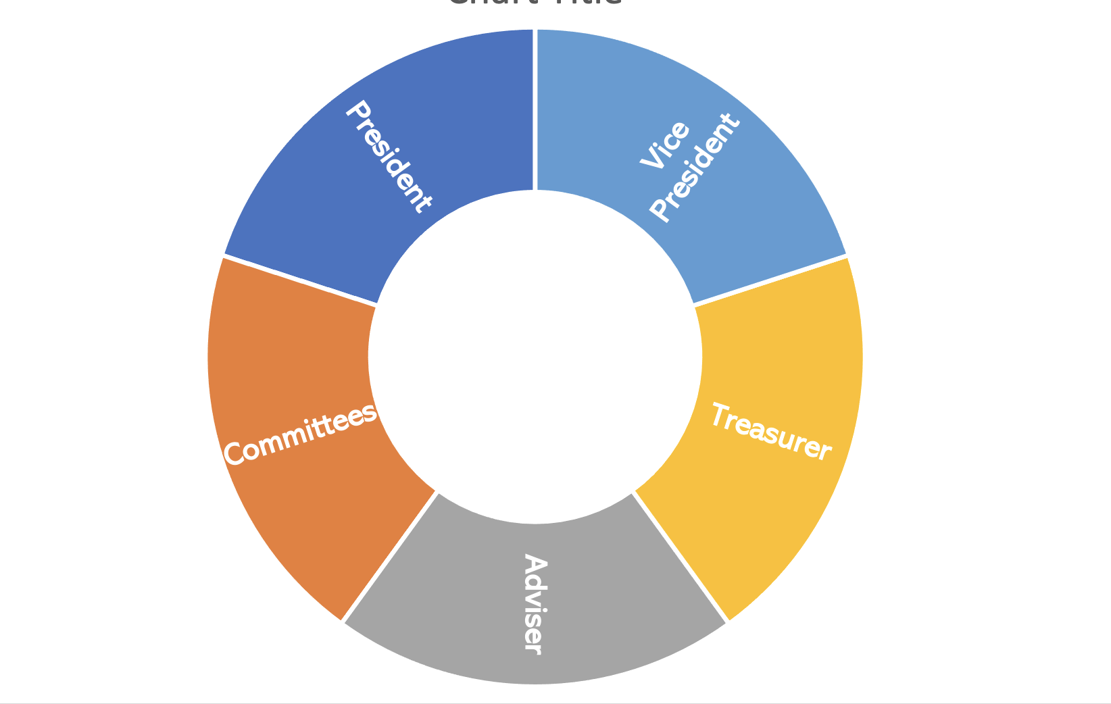

Article VIII: Officers and Responsibilities
Section 1: Officers and Executive Board
The club shall have a President, Vice President, Treasurer, and Advisor. The President, Vice President, Treasurer, and Advisor will comprise the executive board.
Section 2: Responsibilities of President
- The president shall be the chief executive officer
- With the approval of the executive board, the president shall name all committees.
- The president shall appoint all committee directors
- With the executive board’s approval, the president may open new positions not listed on this document to fit the club’s needs and its members.
- Vacancies in offices will be filled by a student appointed by the president, with the executive board’s approval.
- Create and implement academic and professional development opportunities for students
- Open the meetings at the designated time by calling it to order.
- Make the necessary announcements in order and share the floor with other officers.
- Recognize and place in vote any questions or motions stated in the meeting.
- Enforce the requirements and rules according to the particular circumstance within the meeting.
- Respond to any questions of any member regarding the matter of discussion of the meeting.
- Authorize the club’s events and provide his/her/their signature when needed along with the Vice-President.
- Declare the meeting adjourned when the end time comes or when the club members have no further business.
- Approve all reports given in the meeting by the other officers.
- Prepare before each meeting an agenda to be followed with the Vice-President.
- Represent the club in any other event, if necessary. Prior approval of the executive board is needed.
- Work with the rest of the Cabinet to achieve the club’s purpose and goals.
- Keep an accurate record of reports in the positions’ binder.

Section 3: Responsibilities of Vice President
- Keep a record of the discussion summaries of the meetings.
- Authorize the club’s events and provide his/her/their signature when needed along with the President.
- Manage and organize the committees.
- Give support and assistance to all other officers.
- Take the place of the President in the case that he/she/they is absent.
- Represent the club in any other event, if necessary. Prior approval of the executive board is needed.
- Work with the rest of the cabinet to achieve the club’s purpose and goals.
- Keep an accurate record of reports in the position’s binder.

Section 4: Responsibilities of Treasurer
- The Treasurer shall keep a current record of all financial transactions
- The Treasurer will be responsible for checking the accuracy of all bills and invoices and paying them correctly and on time.
- The Treasurer will perform other duties as directed by the president.
- Collect any dues established by the executive board
- Take Treasurer training provided by Student Engagement
- Utilize P-card to make club purchases as established by the Campus Organizations Accounting Office

Section 5: Office Term
The term of office shall be at least one semester and a maximum of one full academic year or two consecutive semesters. The first semester should always be Fall, unless the officer is replacing an elected officer. The officer may leave its position at any time (2 weeks of noticed suggested).
Section 6: Requirements
The officers of this organization must meet the following requirements:
- Officers must be members of the Political Science Club
- Be in good standing with the university and enrolled:
- if an undergraduate student at least half time (six or more credit hours), unless fewer credits are required to graduate in the spring and fall semesters during the term of office, and at least half time (four or more credits),
- if a graduate-level student (unless fewer credits are required in the final stages of their degree as defined by the Continuous Registration Requirement) during their term of office.
- Have a minimum cumulative grade point average (GPA) as stated below and meet that minimum GPA in the semester immediately prior to the election/appointment, the semester of election/appointment, and semesters during the term of office.
  - For undergraduates, the minimum GPA is 2.00.
  - Graduate and professional students need a 3.0 GPA to remain in good academic standing.
    - For this provision to be met, at least six hours (half-time credits) must have been taken for the semester under consideration. Exceptions may be made with a unanimous vote of the executive board.

Article IX: Risk Management
Section 1: Risk Management
The Vice President shall also serve as the risk management office for the organization. The role of the risk management officer is to:
- help minimize potential risks for club activities,
- recommend risk management policies or procedures to the club,
- submit documentation to ISU's Risk Management Office and
- to ensure that Iowa State University policies are followed at all of the organization's events and
- to ensure that proper waivers and background checks are on file with Risk Management for events, as applicable.

Article X: Elections
Section 1: Elections
- Election of officers shall be held each within the first three weeks of April.
- At least two weeks' notice shall be given before the election meeting.
- Voting will occur at a general meeting.
- Non-present members may vote at the same time of the general meeting
- At the voting meeting, each candidate will have 2 minutes to speak in front of general membership to share why they should be elected to their desired position(s).
- Elections must be done by an anonymous electronic ballot using qualtricts.
- The ballot shall be created by the president and approved by the advisor.
- The president must not create the ballot if running for reelection.
- The person receiving the majority vote will be elected.
- Honest efforts should be made to share available positions with all the membership.
Section 2: Ties
- In the case of a tie, an immediate run-off election will be held between the tied candidates. Voting will occur by secret ballot in which members will write the name of their chosen candidate on a piece of paper and submit it to the outgoing President.
- In the case that no candidate receives a majority vote, an immediate run-off election will be held between the two highest voted candidates. Voting will occur by secret ballot in which members will write the name of their chosen candidate on a piece of paper and submit it to the outgoing President.

Section 3: Running for an officer position
- All positions should be announced during the month of March through email.
  - Honest efforts should be made to share available positions with all the membership.
- Members interested in running for an officer position will complete a nomination form created by the executive board.
  - The form must be submitted to the board at least one week prior to the general membership vote.
- As established in Section 4 of Article VIII, the term of office shall be at least one semester and a maximum of one full academic year or two consecutive semesters. The first semester should always be Fall, unless the officer is replacing an elected officer.

Article XI: Vacancies, Replacements, and Removal of Officers

Section 1: Vacancies
- In the case of an officer vacancy, a special election must occur within one week of the position being vacated.
- Special elections must follow the same format as annual elections, outlined in Article X Section 1.
- If no candidates come forward for the position, the officers may appoint a general member to the position with the member’s approval.

Section 2: Vacancies during term and replacements
- Any vacancy, which may occur in an office, shall be filled by appointment by the president in seven days or less, with the approval of the advisor.
Section 3: Removals
- Officers can be removed from their position by a majority vote of club membership present at the voting meeting.
- Grounds for removal include, but are not limited to:
- Failure to uphold the responsibilities of the position
- Steal club funds
- Misuse club property
- Fail to fulfill their duties
- Violate the school’s Code of Conduct
- Commit Sexual Improprieties
- Utilize racist or derogatory vocabulary with the intent of hurting
- Physically attacks a member of the club during a club meeting or event
- Presents threatening or aggressive actions, aggressive behavior, harassment of any kind (verbal, physical, social, sexual), bullying, including cyber/electronic, and intimidation
- Other grounds for removal will be determined by the highest-ranking officers not in question for removal.
- Any club member may initiate the removal process by bringing a written request for removal that include the reasons for removal to the highest-ranking officer not in question for removal.
  - The officers will hold a special meeting with the Advisor to deliberate.
  - The officers (excluding the officer in question) and Advisor must have a majority vote of approval of all officers to move the removal process to a general membership vote. The officer in question may not be present for the officer vote. Officers will vote by a show of hands.
- Voting will be conducted by secret ballot at a general meeting.
  - The vote will be announced at least one week prior to the meeting.
  - The voting method will be an anonymous virtual ballot prepared by the highest-ranking officer not in question for removal.
  - The officer in question must be provided a summary of the reasons for removal at least one week in advance of the vote.
  - The officer in question will be allowed to speak to membership for a maximum of 5 minutes before voting occurs.
  - The officer in question will be asked to leave the meeting while deliberation and voting commences.
  - The officer in question will be informed of the results and be allowed access to the ballots if requested.
- The officer in question may attempt to appeal the results of the vote by contacting the Advisor of the organization and submitting a written statement. The advisor must respond with their decision within 10 days. No secondary appeals will be permitted.

Article XII: Removal of Members
Section 1: Removals
- Any member can be removed from the club by a majority vote of club membership present at the voting meeting, excluding the member in question.
- Grounds for removal include, but are not limited to:
- Steal club funds
- Misuse club property
- Fail to fulfill their duties
- Violate the school’s Code of Conduct
- Commit Sexual Improprieties
- Utilize racist or derogatory vocabulary with the intent of hurting
- Physically attacks a member of the club during a club meeting or event
- Presents threatening or aggressive actions, aggressive behavior, harassment of any kind (verbal, physical, social, sexual), bullying, including cyber/electronic, and intimidation
- Other grounds for removal will be determined by the executive board.
- Any club member may initiate the removal process by bringing a written request for removal that include the reasons for removal to the executive board.
  - The officers will hold a special meeting with the Advisor to deliberate.
  - The officers and Advisor must have a majority vote of approval of all officers to move the removal process to a general membership vote. Officers will vote by a show of hands.
- Voting will be conducted by secret ballot at a general meeting.
  - The vote will be announced at least one week prior to the meeting.
  - The voting method will be an anonymous virtual ballot prepared by the highest-ranking officer not in question for removal.
  - The member in question must be provided a summary of the reasons for removal at least one week in advance of the vote.
  - The member in question will be allowed to speak to membership for a maximum of 5 minutes before voting occurs.
  - The member in question will be asked to leave the meeting while deliberation and voting commences.
  - The member in question will be informed of the results and be allowed access to the ballots if requested.
- The member in question may attempt to appeal the results of the vote by contacting the Advisor of the organization and submitting a written statement. The advisor must respond with their decision within 10 days. No secondary appeals will be permitted.

Article XIII: Advisor
Section 1: Responsibilities of Advisor
The Advisor shall:
- Assist the group in the execution of roles and responsibilities
- Provide feedback to the organization regarding its operation and functioning
- Serve as a resource in navigating the school administration
- Provide advice upon request, and also should share knowledge and expertise
- Be a full-time faculty or staff member of the school
- Be a nonvoting member of the organization

Section 2: Selection of Advisor
The Advisor will be selected by the president and Treasurer based on his/her/their background in politics, political science, career and academic development, and/or relevant subjects.
Section 3: Advisor’s term of service
The Advisor agrees to serve at their leisure. Term is renewable at the agreement of the Advisor and officers.
Section 4: Vacancies and Replacement
The President, Vice President, Treasurer are responsible for selecting an appropriate replacement within seven days of the vacancy.
Section 5: Removal
- If the president and Treasurer decide to put the Advisor up for removal, they must announce a meeting of the general membership to vote with at least one week's notice.
- The Advisor must be notified and given reason for removal at least one week prior to voting.
- The Advisor will be given the opportunity to speak in front of the club officers before a final decision is made. The Advisor may speak for 5 minutes, then they must leave the room while voting and deliberation occurs.
- The majority vote of members present at the meeting must vote in support of removal for the Advisor to be removed.
- The Advisor will be notified of the decision via email.

Article XIV: Finances and Fundraising
Section 1: Finances
The political science club will raise funds to support its activities through donations, fundraisers, the Political Science department, the ISU Foundation, and other relevant campus programs, as permitted by University regulations.
Section 2: Fundraising
- The executive board must work with enough time to meet the deadlines for grants and scholarships. Students of the executive board should refer to the Advisor for departmental grants and funding opportunities. The club should plan to get enough funding to cover the cost of promotional material (physical and digital) and field trips. The club may accept donations to cover the costs of club-related activities.
- All monies belonging to this organization shall be deposited and disbursed through a bank account established for this organization at the Campus Organizations Accounting Office or approved institution/office (must receive authorization via Campus Organizations Accounting Office). All funds must be deposited within 48 hours after collection. No purchase should be made without the approval of the Treasurer. The executive board must be notified of these purchases.

Article XV: Amendments and Ratification
Section 1: Amendments
- Amendments to the constitution may be proposed by any member in good standing.
- Any amendment must be announced two weeks in advance of a voting meeting.
- The amendment must receive a two-thirds vote of approval to be instated.
- The president must send an amended or ratified constitution to the Student Activities Center for approval within ten days of ratification or amendment.
Section 2: Ratification
This constitution will be voted on and approved by the executive board, after it being approved by the Student Engagement Office.

