Frederiksen Court Community Council
Meeting Agenda for Sunday, December 11th, 2022, 7:00 pm, PDR
--
Points for General Meeting:
- Introduce elected officers, RA Liaison, and Stu Gov Rep for Spring 2023
  - Introduce any current officers in attendance whom are not continuing for Spring
- What is FCCC?
- Recap of events from Fall 2022
  - Community Improvement Survey
  - DnD Campaigns
  - Pumpkin Painting Contest
    - Consider doing plastic pumpkins for future years
  - Board Game Night
  - FC Safety Walk with Facilities
  - Insomnia Cookies
    - Note to reach out to Cay to have the quantities of each cookie ordered
      - Need more double chocolate chip
      - Less sugar, vegan, peanut butter chip? - these were the flavors with leftovers
  - Food Drive for SHOP
    - Running from 12/12 to 12/16
    - Members to drop off at SHOP
      - Open from 11 am to 4 pm on 12/16
- Some important notes regarding joining FCCC
  - Meeting times for Spring: Sunday from 5-6 pm in the PDR
  - Who is a voting member?
    - Members of Council who are eligible to approve purchases
    - Includes: President (the Chair), Treasurer, Secretary, Webmaster, All Cluster Reps, All At Large Members
    - Does not include: RA Liaison(s) and Student Government Rep(s)
  - How do we get things approved?
    - At least 2/3 voting members must agree to a purchase
  - (Via the constitution) “A. Attendance
    - 1. All voting Council members shall attend every meeting unless an absence is excused by the Chair. Council members who have planned absences shall notify the Chair 24 hours in advance, using email.
      - i. Some examples of excused absences may include sicknesses, class/school activities, religious accommodations, inclement weather, and other instances on a case-by-case basis as discussed with the Chair via email.
      - ii. If less than 24 hours’ notice is given, the Chair must determine if the absence is excused based on the Council member’s ability to have notified previous to the 24-hour window.
    - 3. The secretary will keep a record of unexcused and excused absences, as reported by the Chair, in the minutes.
    - 4. Three unexcused absences per semester may result in removal from the Council.
    - 5. Being 15 minutes late to meetings, unless previously excused, will result in an unexcused absence, on a case-by-case basis. Communicate with the Chair using email or GroupMe.”
- Discuss filling Cluster Representative positions and At Large Member positions
  - 10 -
  - 20 -
  - 30 -
  - 40 -
  - 50 -
  - 60 -
  - 70 - Hannah
  - 80 – Roxxie Bell
  - At Large 1 -
  - At Large 2 -
  - At Large 3 -
- Look at Calendar for Spring 2023
- 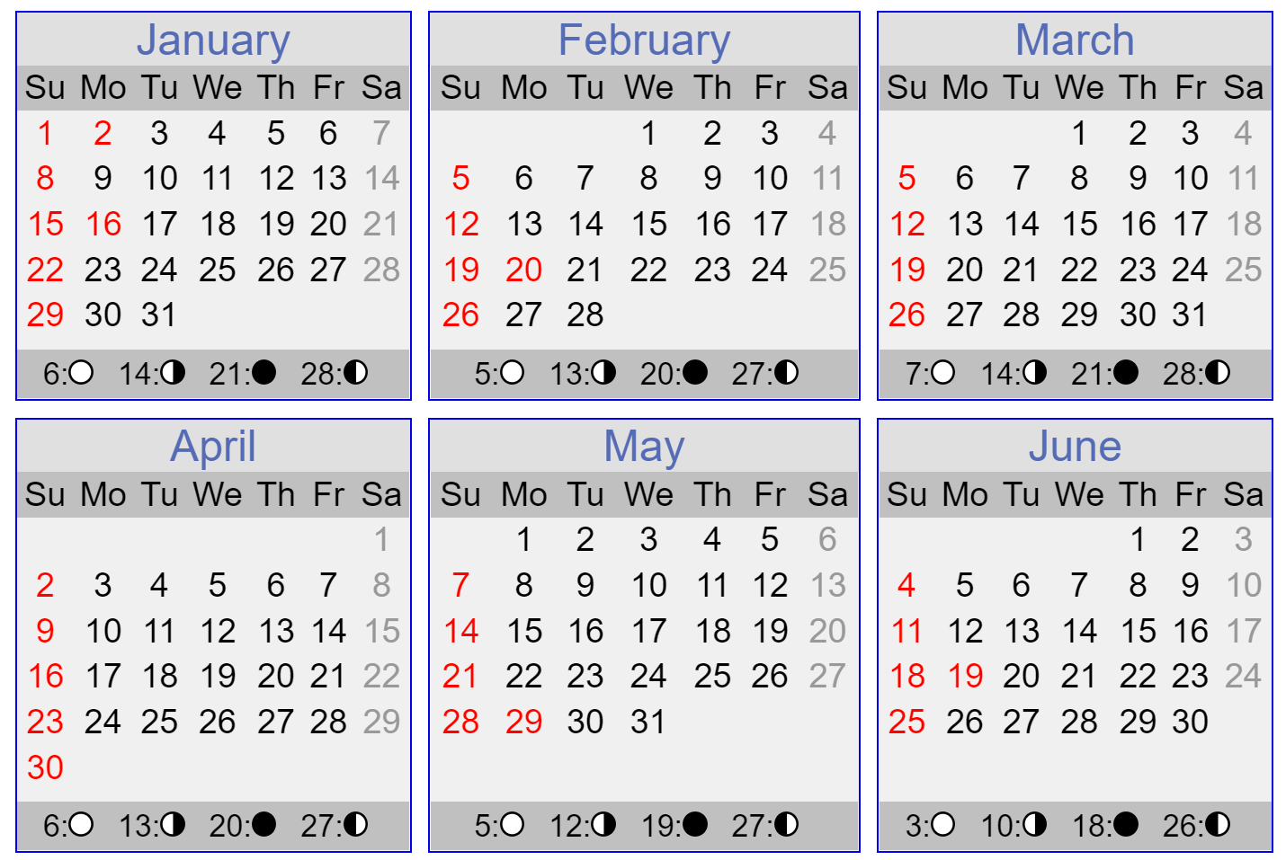
  - What other event ideas do we have?
    - Free pizza event?
    - Something artsy?
  - January
    - 17th: First Day of Classes
    - 22nd: First FCCC Meeting
  - February
    - 16th: Game Night
    - 28th: Succulent Potting
  - March
    - 7th: Game Night
    - 11th – 19th: Spring Break
    - 24th: Trivia Night
    - Begin preparing for FCCC election in April, for Fall 2023
  - April
    - 6th: Game Night (or see if Tuesday was more popular and do on the 4th)
    - Basketball tournament
      - Week of 24th – 28th
    - 30th: Prep Week Snacks Event
      - Gift card prizes? Opportunity drawing?
      - Pizza and energy drinks
    - Hold Fall 2023 elections
  - May
    - 8th: First Day of Finals Week
  - Note that RA’s will have Bingo either January 27th or February 3rd
⁻⁻
Points for Individuals:
- Aren (Resident Assistant Liaison)
  - Attendance Policy for Spring: Attend first meeting of the semester. Depending on event planning time line, may attend every other or every third meeting. If every other attendance is occurring, you will most likely not need to attend FCCC events.
- Emma (Webmaster)
  - Update StuOrg Page with open positions, meeting times, and board game night events for spring
- Khushi (Student Government Representative)
  - Attendance Policy: Send Lauren weekly communications to recap Student Government happenings. Meeting attendance requested when a policy/issue affects Freddy Court or FCCC. Meeting attendance may be requested when FCCC has an issue to bring before Student Government.
- Lauren (President)
  - Send out recap email
  - Add new Cluster Reps / At Large Members to Student Organization page, GroupMe, and CyBox
  - Send out reoccurring calendar for FCCC meetings in spring, based on meeting time selected
  - Update recruitment google form with open positions
  - Over break: create plan for meeting topics for spring semester meetings
  - Attend North and South RA meetings upon returning from break
  - Ask RAs on Newsletter collateral about how to get event information inside
    - Timeline, space, etc.
- Madison (Treasurer)
  - When available: complete treasurer training and apply for a p-card
  - Work on proposal for automatic door concerns
  - Ask Cayann about how much printing services were for flyers
  - Attend North and South RA meetings upon returning from break
- McKenna (Secretary)
  - Work on proposal for automatic door concerns
  - The attendance sheet has a new tab at the bottom for spring
    - Please feel free to organize how you want, as this will be your base for organizing attendance
  - If time during break allows for “historian” type tasks, like creating a document with the events we hosted this fall, how events were set up, how they ran, etc.
  - Reach out to Cay about Insomnia Cookie quantities
    - Include this in abovementioned document

